1.Open Excel

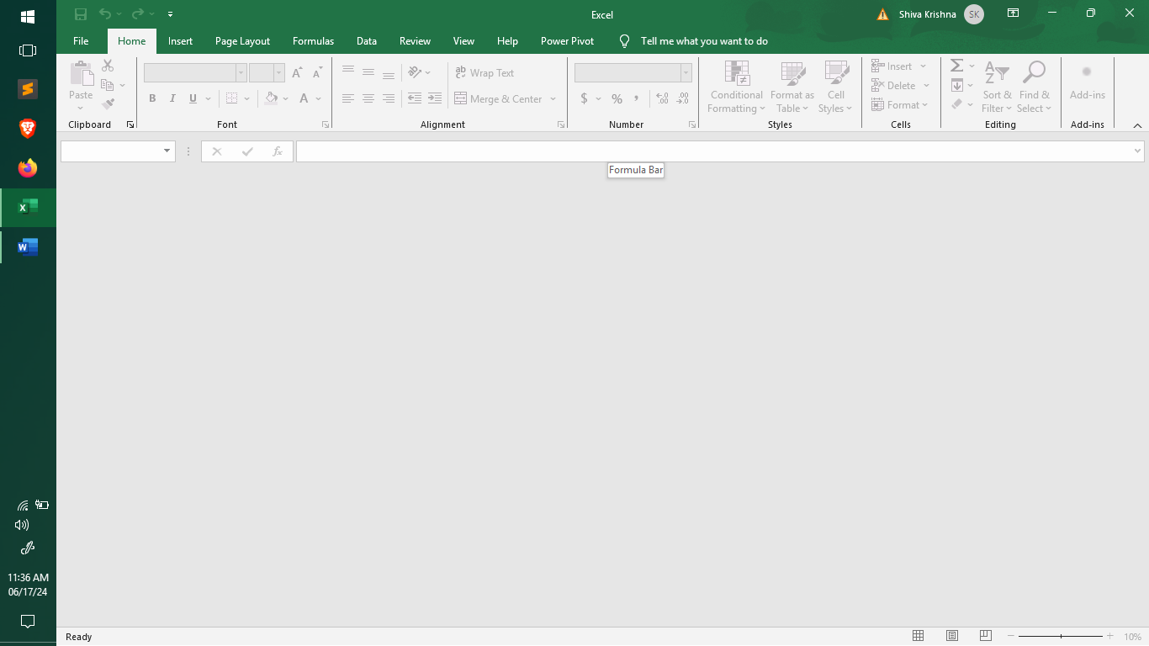

Go to File -> Click on Options

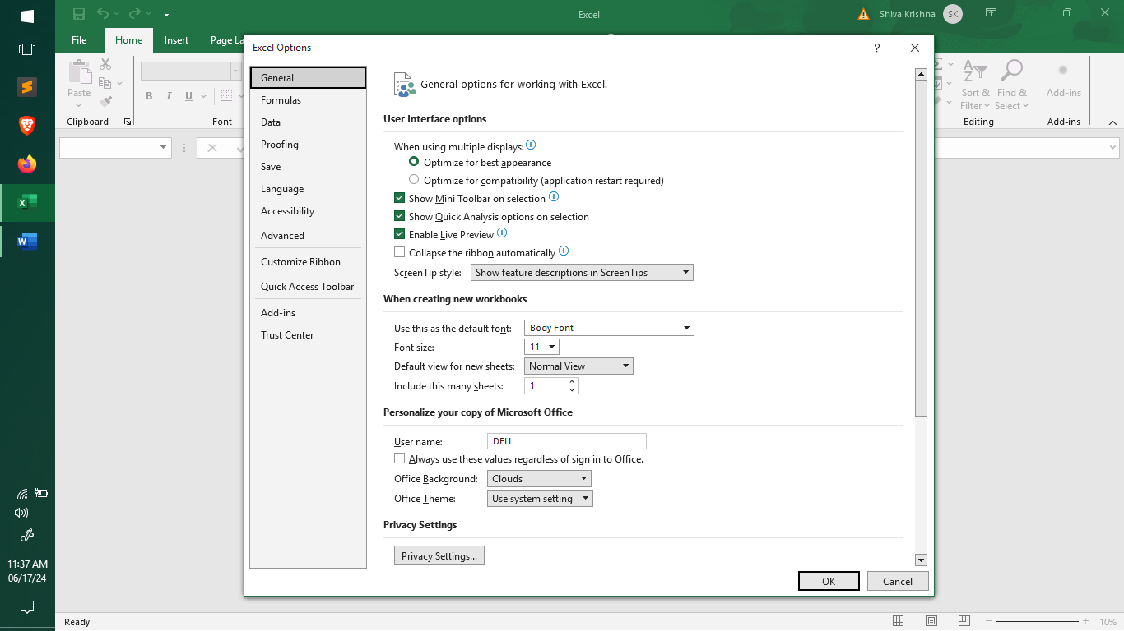

* Go to Add-ins

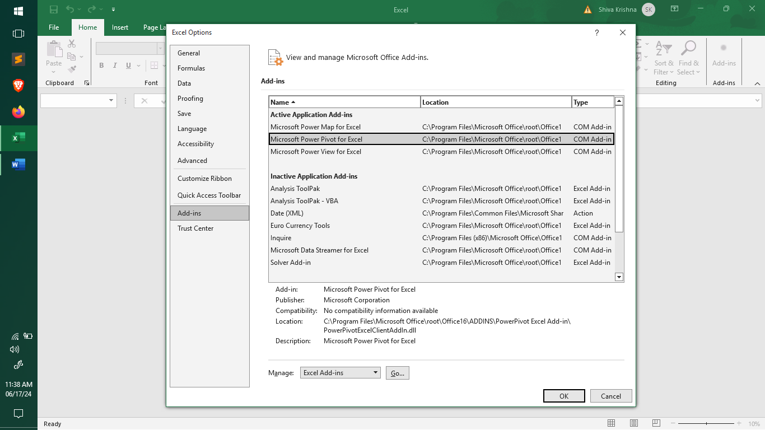

* Select Power Pivot then
* Click on Manage select on “COM Add ins” and then click go

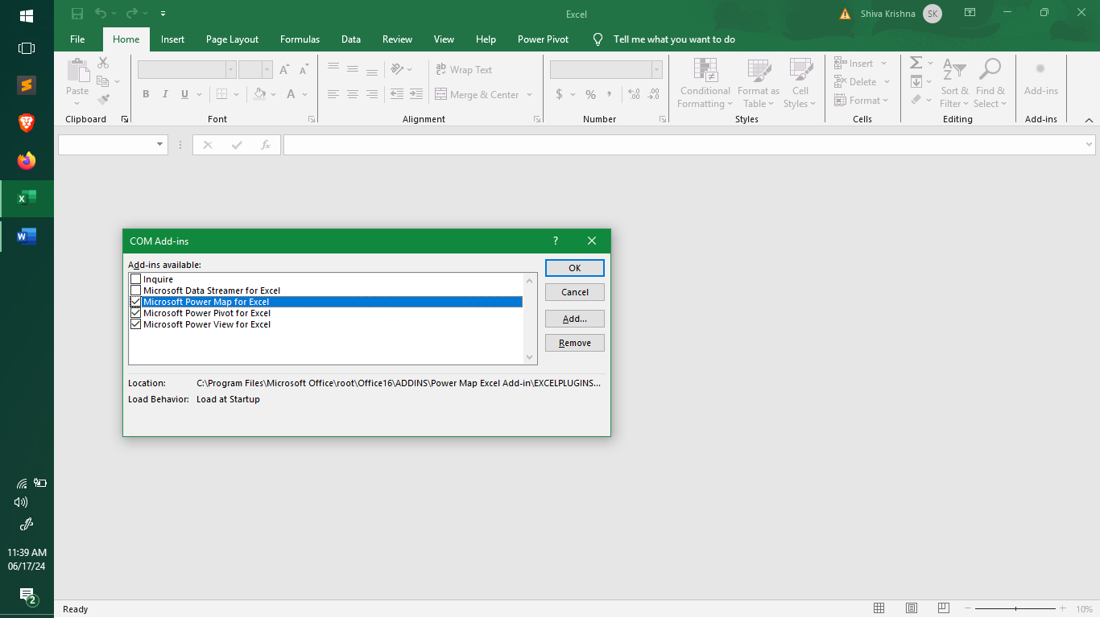Enable Power Pivot and click ok

